Learning Journal

Contents
Variables 1
Serializefield: 2
Private: 2
Float: 2
#Region & #Endregion: 2
ShaderGraphs 4
Width: 4
Height: 4
Rotation: 4
Outline: 4
Fill: 5
MainMenu UI 6
References. 6

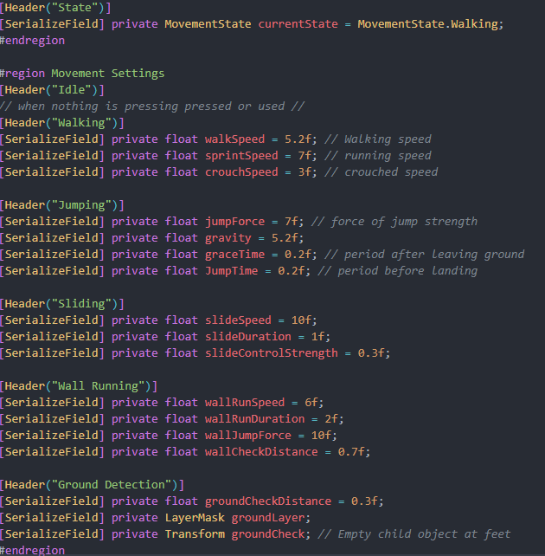
Variables
[SerializeField] private float, which does as follows:

The picture above shows the input system movement character controller states. Allocated with values, which initiates them into variables.

Serializefield:
Variables make it so that in the Unity Inspector, you can modify code in the game without always going back through the script.

Private:
A variable makes it so that code that is made through the script privately can only be used or accessible via being in the same class function

Float:
A float variable is used to handle numbers; may it be one whole number or decimals.
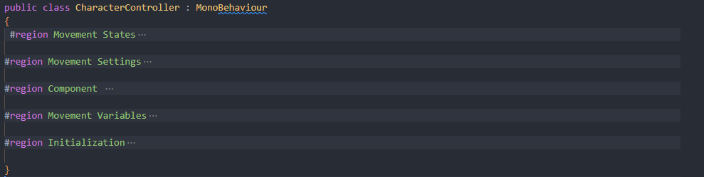

#Region & #Endregion:
The primary purpose of using #region and #endregion is that they enable programmers to organise code within a company or by large groups of programmers for daily use.
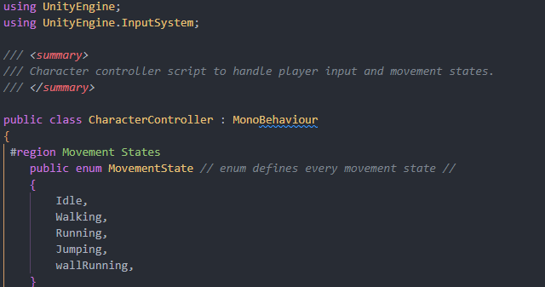

Enum:
Controls the definition of movement, whether that be by update or fixed update, or input, which also helps with gravity.

Understanding the variables for programming was quite interesting because making sure the variables were correct and working together was great when I had to initialise them.

ShaderGraphs
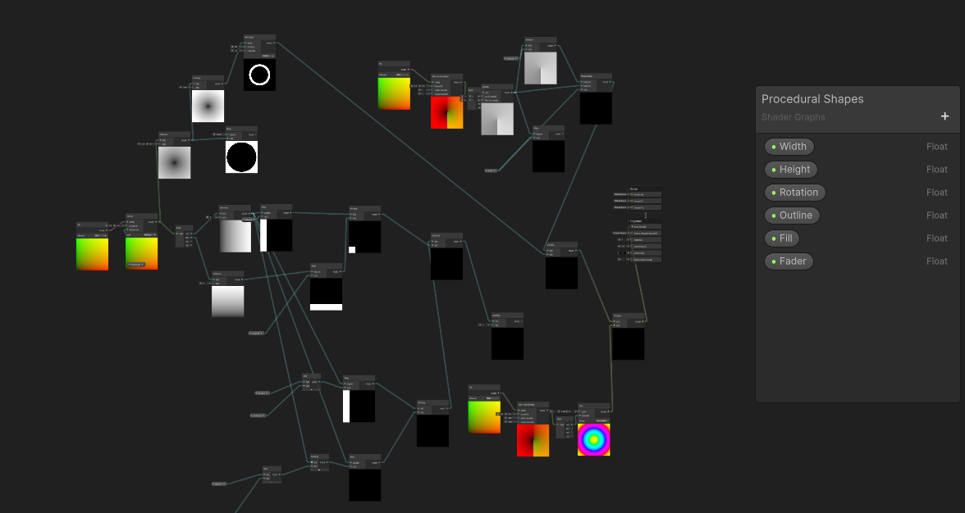

Width:
A float is named Width that is given the variable float which controls the Width of the shader grape cube.

Height:
A float is named Height that is given the variable float which controls the Height of the shader grape cube.

Rotation:
A float is named Rotation that is given the variable float which controls the rotation of the shader grape cube.


Outline:
The outline defines from the height and width of the shader to make outline of the shader give it a border of the shader such as a cube for the given an effect need for the process of the shader graph.

Fill:
A float is named fill which is given to the shader graph which helps turn square or cubed get circular coordinates which are given by getting Uvs into Polar coordinates into a split then step which make able to control how much is filled shown below with control in half and full, with a slider.
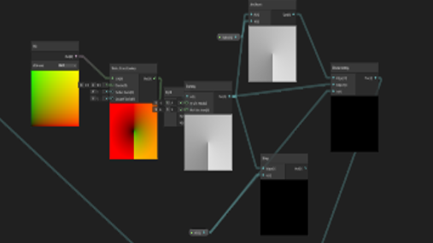

MainMenu UI
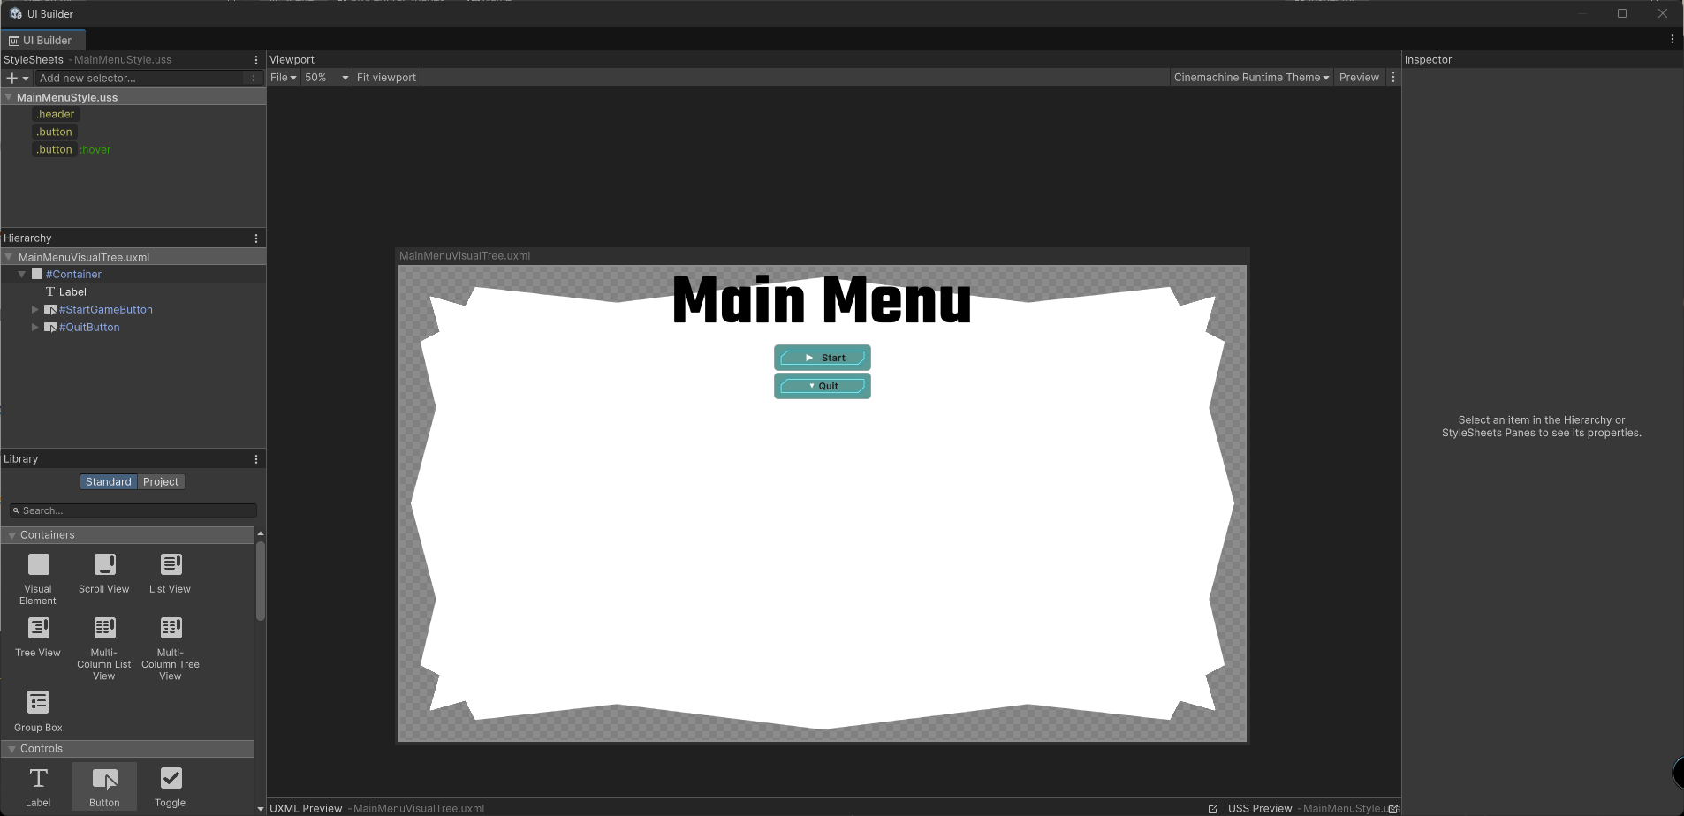

Header
A Header for the main menu in the images above. It contains the name of the main menu.
Button
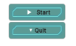
The buttons contain the start and quit buttons that makes the game be able to be played and quit.

The problems that I had with the main system was correctly align the “Start” and “Quit” button in the middle of the screen. Worked perfectly when using my home screen but not at the university screen.

References.
(March 14, 2024) YouTube. Available at: https://youtu.be/_jtj73lu2Ko?si=Ue8D-faVeTu8m9bH (Accessed: 15 December 2025). (UI Toolkit)
(Feauray 6 2021) YouTube Available at:
https://youtu.be/rVeS7oh3oug?si=fxRNmAPln9yQpboV (Accessed: 15 December 2025). (Shader Graph)

